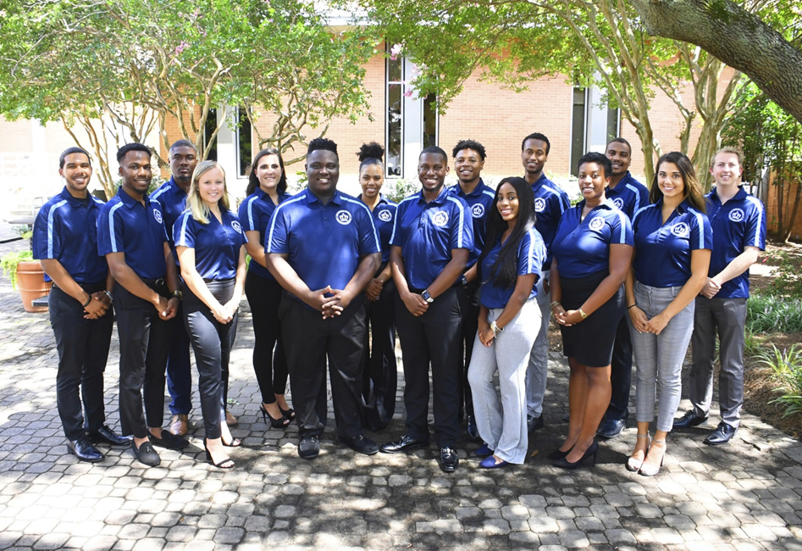

Executive Board Meeting Agenda
11/01/2018 @3:00pm
Senate Chambers

- Guest Speaker/Presentation
  - Chandler, Caitlin B.
-ODU rebranding update
- Barry Art Museum Update, Nov. 14th 4pm-7pm
  - Nicole Kieger
-Student Rights and Freedom Revising almost finished
-Discuss edits and suggestion with Dr. P
- Executive Board Action Items:
  - Executive Tune Up
  - Executive Board Accountability
- Student Organization Co-sponsorship Voting
  - None
- Reports
- President/Vice President Report
- President – Isaiah T. Lucas
-Working on Break the Stigma Event
-Working on bylaws updates
-SGA Cares for November

- Vice President – Juwan Jacobs
-Webb Council meeting Nov. 16th
-Google Drive
- Senator polos need to be ordered
-Committee meeting minutes need to happen
-Break the Stigma Event Nov. 15th
-Busses secured
- 4:20 Report
  - Treasurer – Mohamed Fidail

  - Student Life: Stephen Greiling
-Working on three resolutions
-Working with OIR on supporting the women’s basketball teams

- SGA Finance Reports
- Director of Finance – Kyle Ogle
-No Report
- Secretary/ Chief of Staff Report
- Secretary – Jamilah Wesley
-Encourage senators to do your office hours
- Chief of Staff – Jazmyn Bremby
-Breathe
- Legislative Branch Report
- Speaker Pro Tempore: Alyssa Hesnson
-No Report
- Speaker of the Senate: Tarik Terry
-No Report
- Judicial Branch Report
- Chief Justice: Haley Naquin
-Shut down impeachment rumors
-Carry weight of others if need be
- Director Reports
- Admin Affairs: Alexis Swider
-Finishing sanitation wipe survey
-Exam Jam in Dec. 3rd

- Wellness and Sustainability: Jeff Williams
-Meeting with Nicole merchant to add more H20 water systems
-Adding 27 recycle bins around campus
-Meeting with counseling services next Friday to discuss impacted groups

- Public Relations & Recruitment: Kyrin Sims
-Updating the website
-Adding minutes and committee description

- Legislative Affairs & Diversity: Nyasha Osifeso
-Working with international students about DACA recipients about infinity groups
-GA Day date coming soon

- Off Campus Life & Satellite Campuses: Malik Lawrence
-No Report

- Safety & Transportation: Alexander Evans
-Anessa point of contact with Transportation office
-Possible shopping trip to Premium Outlets with Transportation Department
-Parking Pass distribution coming soon for Spring Semester
-Meeting with ODU PD about Promo video about office campus safety
-Campus walk through going well

- Advisor Reports
- Chief Advisor: Dr. Don Stansberry
- LSI Advisor: Dr. Keiwana Perryman
-ODU Founders day luncheon tomorrow 12-2pm
- Doctoral Advisor: Preston Reilly
- Graduate Advisor: Megan Hare
- What’s happening on campus?
- Adjournment

