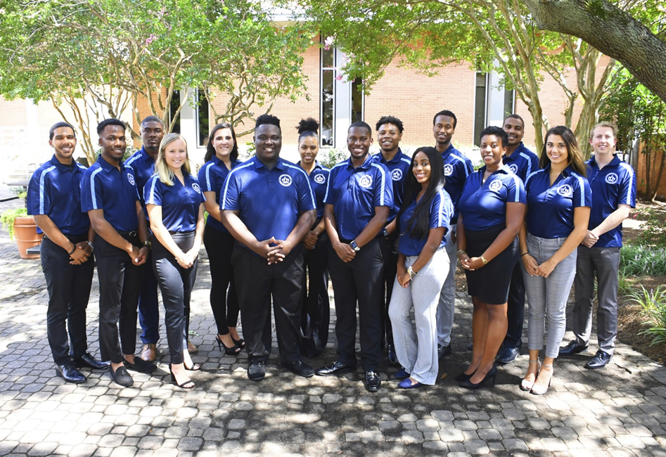

Executive Board Meeting Agenda
09/20/2018 @3:00pm
Senate Chambers

- Executive Board Action Items:
  - Pride Rock
- How to combat hate speech on rock, everyone take part in covering rock
- SGA can paint over anything deemed derogatory
- Groupme will be used to post when the rock needs to be painted over
  - Campus partner check in
- Everyone has emailed campus partners
  - Director Check in with for Retreat
- Directors email committee memebrs inviting them t the retreat
- Guest Speaker/Presentation
  - Don Stansberry - Dean of Students & Associate Vice President
- Goal Setting
- Student Organization Co-sponsorship Voting
  - No pending requests
- Reports
- President/Vice President Report
- President – Isaiah T. Lucas
-SGA is doing great with interacting with students
-Cultivate the crown logo illegal, the hashtag with stay
-Reign on when you see someone cultivate the crown!
-SGA cares in full swing
- Vice President – Juwan Jacobs
-Shoutout to Malik and Jeff! Keep up the great work!
-13 spaces open for the retreat
-Room assignments aren’t mandatory
-An email will go out tomorrow about what you need to bring
- SGA Finance Reports
- Treasurer – Mohamed Fidail
-Plan for homecoming
-Cosponsorships and contingency: Haven’t received any yet
- Director of Finance – Kyle Ogle
-Fiscal year calendars have been ordered
-Finance Committee meeting from 5-7pm Thursday’s
- Secretary/ Chief of Staff Report
- Secretary – Jamilah Wesley

- Chief of Staff – Jazmyn Bremby
- Office Hours are from 8am-7pm, Monday – Friday
- -Get the Scoop Social, Mondays at 6:30pm -7:30pm in the Norfolk Room (Sept. 24th)
- Tailored Tuesday’s for SGA
- Legislative Branch Report
- Speaker of the Senate: Tarik Terry
-Alex Grey sits on Admin Affairs Committee
-Brandy Ramsey sits on Wellness & Sustainability
-Senator Induction Dates: Sept. 25th, Oct. 2nd, Oct. 30th, Nov. 27th, Dec. 4th
- Speaker Pro Tempore: Alyssa Henson
-N/A
- Judicial Branch Report
- Chief Justice: Haley Naquin
- Director Reports
- Admin Affairs: Alexis Swider
- Wellness and Sustainability: Jeff Williams
-Surveys on Mental Health Awareness and also presented to the BOV about the topic
- Public Relations & Recruitment: Kyrin Sims
-Live streaming for Senate meetings
-Pride Patrol tomorrow Friday at 1pm
-Pride shirts arriving next week
- Legislative Affairs & Diversity: Nyasha Osifeso
- Off Campus Life & Satellite Campuses: Malik Lawrence
- Safety & Transportation: Alexander Evans
- Student Life: Stephen Greiling
-To go box survey closes Friday, goal of 350
-Dining Appreciation Day Nov. 6th
Monarch Secret Shopper arriving soon
- Advisor Reports
- Chief Advisor: Dr. Don Stansberry
- LSI Advisor: Dr. Keiwana Perryman
- Doctoral Advisor: Preston Reilly
- Graduate Advisor: Megan Hare
- What’s happening on campus?
- Adjournment

