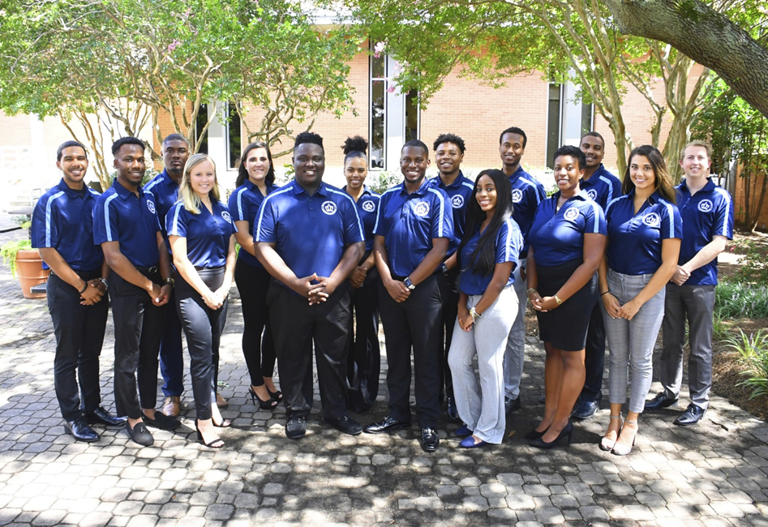

Executive Board Meeting Agenda
10/25/2018 @3:00pm
Senate Chambers

- Executive Board Action Items:
  - SGA Week Recap
-went well, enjoyed working with other committees, great turnout
  - Legislative update
-Director Williams, working on H20 systems
-Director Osifeso, working with the Chief Jusitce on election commissioner
-Director Evans, adding more lights on campus
- Guest Speaker/Presentation
  - None
- Student Organization Co-sponsorship Voting
  - The Indian Student Association for their Diwali event scheduled for November 5, 2018.
    - 9 yays, 1 nays, 1 abstain
- Reports
- President/Vice President Report
- President – Isaiah T. Lucas
-Barry Arts Museum November 14th from 11am-1pm ribbon cutting
-SGA Cares coming up
-Adding SGA Cares under his role and possible name changing
-Break the stigma event coming up Thursday, November 15th 7pm
-Video conducted to discuss the pride rock
- Vice President – Juwan Jacobs
-People felt like the Fall Retreat was well planned, 100% on understanding the degree of teamwork
-Low Ropes course wasn’t a challenge
-Time management should be pushed
-Encourage senators to sign-up
-Committee meetings minutes need to be submitted to they can posted to the website
-Composite photos in the spring
-Legislation workshop needs to happen, working with Tarik on that
-Committee assignments needs to happen
-Directors send in assignments to Secretary Wesley for senators to complete
- Speaker of the Senate: Tarik Terry
- 4:20 Report
  - Treasurer – Mohamed Fidail
-GA Day, want to have things finished by November 15th
  - Student Life: Stephen Greiling
-No Report
- SGA Finance Reports
- Director of Finance – Kyle Ogle
-Online financial workshops coming soon
-Meeting with auxiliary services rep about financial literacy programs
-Next budget workshop, James Lynn Room, 5:30PM Oct. 29th
-Kahoot game went really well
-Please participate in monarch money madness program

- Secretary/ Chief of Staff Report
- Secretary – Jamilah Wesley
-Graduation Stoles, Office Hours
- Chief of Staff – Jazmyn Bremby

-November 7th Office Clean Up Social (along with a presentation of Robert Rules and By-law presentation)
- Legislative Branch Report
- Speaker Pro Tempore: Alyssa Henson
-No Report
- Judicial Branch Report
- Chief Justice: Haley Naquin
-Moving speaker from elected externally and internally
- Director Reports
- Admin Affairs: Alexis Swider
-Exam Jam is Dec. 3rd in the river rooms at 5pm
- Wellness and Sustainability: Jeff Williams
-Met with counseling services, we need more counselors there’s only 7 full-time
-Working on health related community service project
- Public Relations & Recruitment: Kyrin Sims
-3rd place office decorating office
-Pride patrol cancelled
-Live streaming resumes Tuesday
-Pride Swap 2nd week of Nov.
- Legislative Affairs & Diversity: Nyasha Osifeso
-Nomination Committee Bill in progress
-Nov. 5th Office of Survey Infiinity Space
-Jan. 17th or 22nd. With generic business cards
- Off Campus Life & Satellite Campuses: Malik Lawrence
-Collab. With ODU Rent on issues
-Higher Education Center visit Nov. 19th Monday
- Safety & Transportation: Alexander Evans
-Working on What Were You Wearing
- Advisor Reports
- Chief Advisor: Dr. Don Stansberry
- LSI Advisor: Dr. Keiwana Perryman
-Timesheets submitted by Jazmyn, 40 hrs a month
- Doctoral Advisor: Preston Reilly
- Graduate Advisor: Megan Hare
- What’s happening on campus?
- Adjournment

