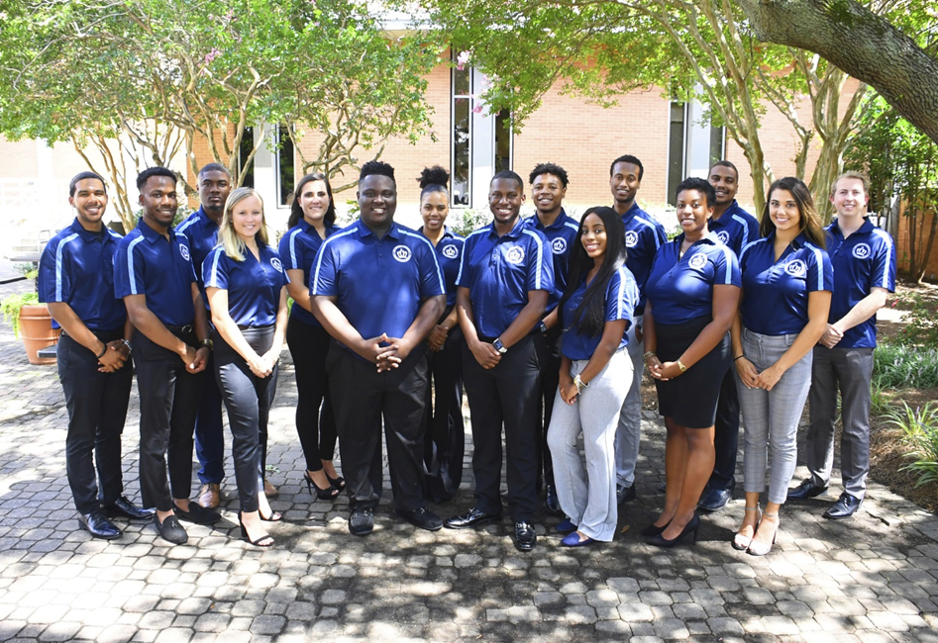

Executive Board Meeting Agenda
09/05/2018 @3:00pm
Senate Chambers

- Executive Board Action Items:
  - Editing and reviewing of the monarch creed
- Feedback morphing my monarchs keeper
- Take the creed, it should apply towards any and everything you do
- Condense the acronym
- How do we get it the creed to “catch on?”
- Guest Speaker/Presentation
  - Nicole Kiger -Director Leadership and Student Involvement
- Any individual students can request space for free speech
- ODU does not sponsor these events
- Speech isn’t protected if it incites a riot, or some other violence
- 1st amendment says we cannot prohibit free speech
  - Jen Cohen – Director of Fraternity & Sorority Life
- Discussed finances and vendors for ordering
- The Do’s and Don’t of contracts, prizes, and traveling
- Student Organization Co-sponsorship Voting
  - No pending requests
- Reports
- President/Vice President Report

- President – Isaiah T. Lucas
- Monarch Creed revamp, September 18th, South Mall Tabling
- Congrats to everyone getting approved
- SGA cares is beginning to start soon

Vice President – Juwan Jacobs
- Webb Council, 3 student org spots left
- Encourage senators to sign up for the retreat
- Keep presentations for the retreat interactive

- SGA Finance Reports
- Treasurer – Mohamed Fidail
- Director of Finance – Kyle Ogle
- Committee meeting from 5pm-7pm, Mane Hub Conference
- Working with auxiliary services about financial literacy workshops
- Secretary/ Chief of Staff Report

- Secretary – Jamilah Wesley
- Encourage senators to complete office hours

- Chief of Staff – Jazmyn Bremby
- Office Hours 8am-6pm
- Social September 6:30 pm – 7:30 pm
- Legislative Branch Report
- Speaker of the Senate: Tarik Terry
- Lengthy presentation should be sent in before hand

- Speaker Pro Tempore: Alyssa Hesnson
- Judicial Branch Report
- Chief Justice: Haley Naquin
- No report
- Director Reports
- Admin Affairs: Alexis Swider
- Working on points and standards

- Wellness and Sustainability: Jeff Williams
- Have a great week

- Public Relations & Recruitment: Kyrin Sims
1.Pride shirts are being orders
2. Pride Patrol next Friday, time TBA

- Legislative Affairs & Diversity: Nyasha Osifeso
- 1st Amendment video coming soon
- Dinner invitation to the delegates in our district

- Off Campus Life & Satellite Campuses: Malik Lawrence
- Committee meeting went well
- Trying to revamp office campus website

- Safety & Transportation: Alexander Evans
- Met with committee yesterday
- Student Life: Stephen Greiling
- Advisor Reports
- Chief Advisor: Dr. Don Stansberry
- LSI Advisor: Dr. Keiwana Perryman
- Doctoral Advisor: Preston Reilly
- Set up 1’1s
- Graduate Advisor: Megan Hare
- What’s happening on campus?
- Adjournment

