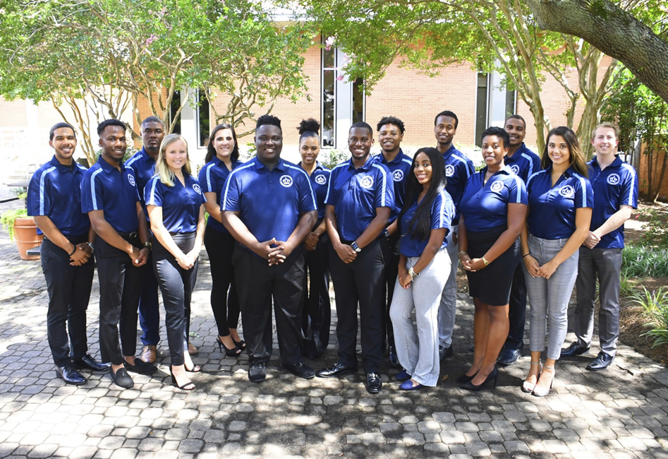

Executive Board Meeting Agenda
10/18/2018 @3:00pm
Senate Chambers

- Executive Board Action Items:
  - Monarch Creed Feedback
- Take out pride and put with confidence
- Survey showed diversity is an important topic
  - Pride Rock Recap
- Confusion on the purpose of the rock?
- Not covering the rock
- Make a public statement to the student body
  - Senate
- Communication was great between senators as well
- Senators did a good job contributing their input

- Guest Speaker/Presentation
  - None
- Student Organization Co-sponsorship Voting
  - No pending requests
- Reports
- President/Vice President Report
- President – Isaiah T. Lucas
-approval rating
-cultivate the crown logo finished

- Vice President – Juwan Jacobs
-midyear evaluations coming up soon
-fall banquet
-wintergreen, Feb. 1st-3rd, link goes live soon
-senator 1:1s
-facilities hanging office pictures
-better job of putting things back where we found them
-dialogue is effective
-next week, interviews are coming

- Speaker of the Senate: Tarik Terry
-discussed the senate fiasco
-ordering polos
-room set up
- 4:20 Report
  - Treasurer – Mohamed Fidail
- Fall Retreat
- Exam Jam
- Senator Polos

  - Student Life: Stephen Greiling
- 4 sleeping pods
- Met with Ms. Lesa, lack of student support for female sports, supporting women’s team, November 29th
- SGA Finance Reports
- Director of Finance – Kyle Ogle
-100 student organizations that attended financial bylaws workshops
-October 29th first budget workshop meeting

- Secretary/ Chief of Staff Report
- Secretary – Jamilah Wesley
-
- Chief of Staff – Jazmyn Bremby
-social went well
-ODU Day at Coleman Elementary Nov. 17th
- Legislative Branch Report
- Speaker Pro Tempore: Alyssa Henson
- Judicial Branch Report
- Chief Justice: Haley Naquin
-Editing the Bylaws
- Director Reports
- Admin Affairs: Alexis Swider
-Exam Jam November 29th
-Free printing program

- Wellness and Sustainability: Jeff Williams
-committee meeting great
-Smoking signs need to be more prominent
-shirts and water bottle came in for event

- Public Relations & Recruitment: Kyrin Sims
-SGA office when well
-Fishing for feedback table went well with student life
-Pride Patrol at 1pm

- Legislative Affairs & Diversity: Nyasha Osifeso
- Off Campus Life & Satellite Campuses: Malik Lawrence
- Safety & Transportation: Alexander Evans
- Advisor Reports
- Chief Advisor: Dr. Don Stansberry
- LSI Advisor: Dr. Keiwana Perryman
- Doctoral Advisor: Preston Reilly
- Graduate Advisor: Megan Hare
- What’s happening on campus?
- Adjournment

