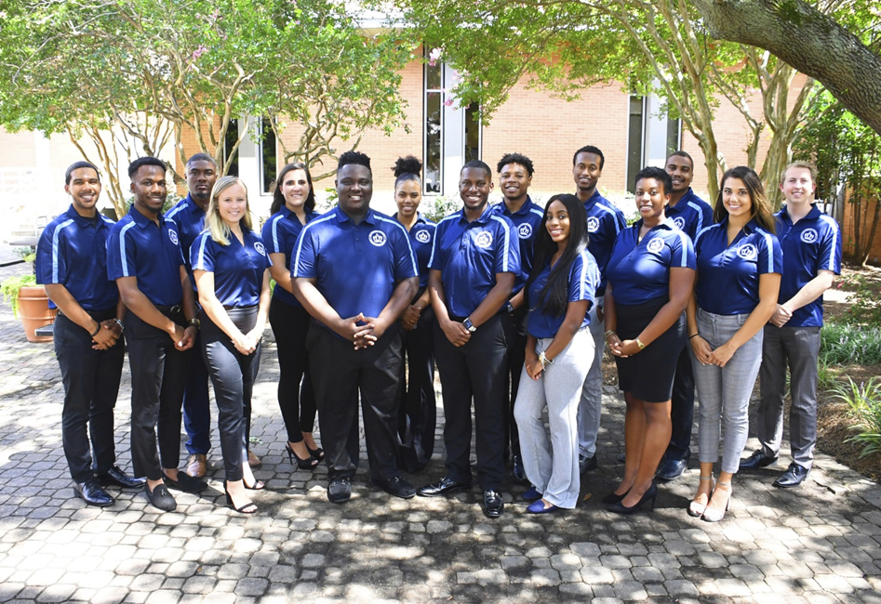

Executive Board Meeting Agenda
11/08/2018 @3:00pm
Senate Chambers

- Guest Speaker/Presentation
  - None
- Executive Board Action Items:
  - Dominion Rock – Kyrin
-Possible monarch link form for reserving rock
-Guidelines for the rock not rules
  - Communication
-questions as far as who to report to?
-
- Student Organization Co-sponsorship Voting
  - None
- Reports
- President/Vice President Report
- President – Isaiah T. Lucas
-Cultivate the crown recognition award being promoted soon
-leading by example
- Vice President – Juwan Jacobs
-working with Jazmyn on the social
-possible senator retreat
-having advisors pictures on slide shows
- 4:20 Report
  - Treasurer – Mohamed Fidail
  - Student Life: Stephen Greiling
-partnering with Nya and OIR for women’s basketball game at 5:30 pm
-dining appreciation card going out soon
-student athlete reserve seat possibly
- SGA Finance Reports
- Director of Finance – Kyle Ogle
-November 12th Money Mondays, SSC Testing center
-November 13th Money Management
-Matching game for senate next week
-workshop training for treasurers next week
-Contingency power point going out next week by Dr. P to show org presidents where to locate form
-Next budget workshop is 3-4 Nov. 14th
-Budget submission form opens December 3rd
- Secretary/ Chief of Staff Report
- Secretary – Jamilah Wesley
- Chief of Staff – Jazmyn Bremby
-social went well, cleaning up and food was great
-senator 1:1’s spread over multiple days
-Nov. 19th 12pm North Café Monarch Family Thanksgiving
-Secret santa google form $10 - $20

- Legislative Branch Report
- Speaker Pro Tempore: Alyssa Henson
-senator orientation
-still interviewing senators
-would like input on different ways to select senators
-asking different questions
- Speaker of the Senate: Tarik Terry
-apologize, haven’t been best self lately
-reserve seats, potentially 3 seats coming open
-met with Karen about senate shirt, about polos we have except for different choices
-up to directors to do attendance infractions for committee meetings
-possible senate seat expansion
- Judicial Branch Report
- Chief Justice: Haley Naquin
-received a CO-OP, possible may have associate justice to replace
- Director Reports
- Admin Affairs: Alexis Swider
- Wellness and Sustainability: Jeff Williams
-Working with Shannon on water systems, as well as use reserve fund in SRC
-working on relocating smoking areas
-Meeting with OCS representative tomorrow
-
- Public Relations & Recruitment: Kyrin Sims
-Pride patrol Friday
-Meeting with Giovanna next week
-
- Legislative Affairs & Diversity: Nyasha Osifeso
-GA DAY form opens Nov. 15TH
- Off Campus Life & Satellite Campuses: Malik Lawrence
-Nov. 18 SGA cares church st., jackets, sweaters, shoes needed
-Nov. 20th Virginia Beach Appreciation 12-1pm, set up at 11:30am
- Safety & Transportation: Alexander Evans
- Advisor Reports
- Chief Advisor: Dr. Don Stansberry
- LSI Advisor: Dr. Keiwana Perryman
-communication needs to be key because we fall under one organization
-change from finance to treasurer needs to happen ASAP!
- Doctoral Advisor: Preston Reilly
-won graduate student of the year
- Graduate Advisor: Megan Hare
- What’s happening on campus?
- Adjournment

