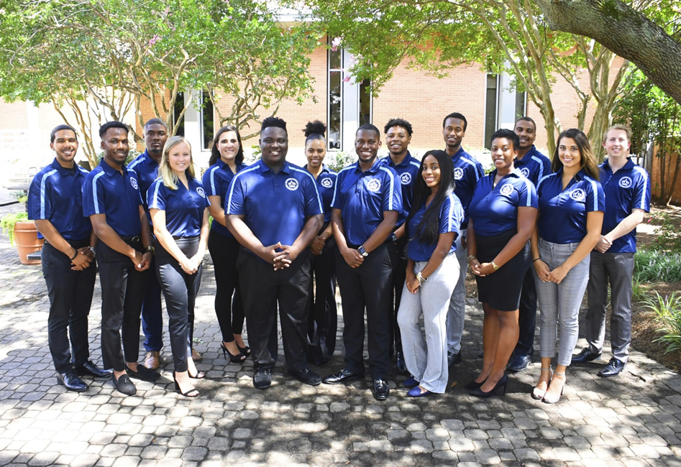

Executive Board Meeting Agenda
11/15/2018 @3:00pm
Senate Chambers

- Guest Speaker/Presentation
  - None
- Executive Board Action Items:
  - Team Builder Activity - Jazmyn
  - Secret Santa - Jazmyn
- Student Organization Co-sponsorship Voting
  - Co-sponsorship – December 1st
- Reports
- President/Vice President Report
- President – Isaiah T. Lucas
-Break the Stigma Event Nov. 15th

- Vice President – Juwan Jacobs
-Payment Dec. 4th of $30
-Social December 6th 6pm
-SAC is planning an event for Monarch Madness (Cochella)
- 4:20 Report
  - Treasurer – Mohamed Fidail
-Payment request deadline is December 7th
  - Student Life: Stephen Greiling
-Met with Kyrin and Giavanna about street signs
-Meeting with housing about virtual tours
-Fill out survey for sleep pod
-Facilities proposal coming soon
- Speaker Pro Tempore: Alyssa Henson
-Send things you want to see for senator orientation

- SGA Finance Reports
- Director of Finance – Kyle Ogle
-Thanks for the matching game
-Contingency legislation coming up after Thanksgiving Break
-Financial literacy olympics challenge brainstorming
-spring budget workshops coming soon
-1st senate of spring it will be a presentation summarizing

-
- Secretary/ Chief of Staff Report
- Secretary – Jamilah Wesley
- Chief of Staff – Jazmyn Bremby
-Possible escape room event
- Legislative Branch Report
- Speaker of the Senate: Tarik Terry
-43 senators
-Changing senate requirements
-possible internship opportunity
- Judicial Branch Report
- Chief Justice: Haley Naquin
-working on updated the bylaws soon
- Director Reports
- Admin Affairs: Alexis Swider
-meeting with rep. from SRC sanitation wipes discount with company
-survey about academic policies
- Wellness and Sustainability: Jeff Williams
-committee meeting went well today
- Public Relations & Recruitment: Kyrin Sims
-pride swap will happen Nov. 16th
-SGA Day Quad Field March 6th; 4pm-7pm

- Legislative Affairs & Diversity: Nyasha Osifeso
-1ODU Meeting wants to lead a movement of what diversity mean
-Application to attend GA Day is on monarchlink

- Off Campus Life & Satellite Campuses: Malik Lawrence
-tabling event went well
-SGA Cares Day is November 18th

- Safety & Transportation: Alexander Evans
-Bird scooter lawsuit with city of Norfolk
-Committee meeting to discuss adding more lights on campus
- Advisor Reports
- Chief Advisor: Dr. Don Stansberry
- LSI Advisor: Dr. Keiwana Perryman
-remember to submit hours on behalf of SGA
-voting strips
-issues with Monarchlink, let Kyrin know

- Doctoral Advisor: Preston Reilly
-support everyone’s initiatives

- Graduate Advisor: Megan Hare
- What’s happening on campus?
- Adjournment

